 | CARA MANTER
 | Mortgage Advisor
 | NMLS-1009328
 | o: | (813) 309-5626
 | c: | (813) 309-5626
 | cara@mclfunding.com
 | www.mclfunding.com

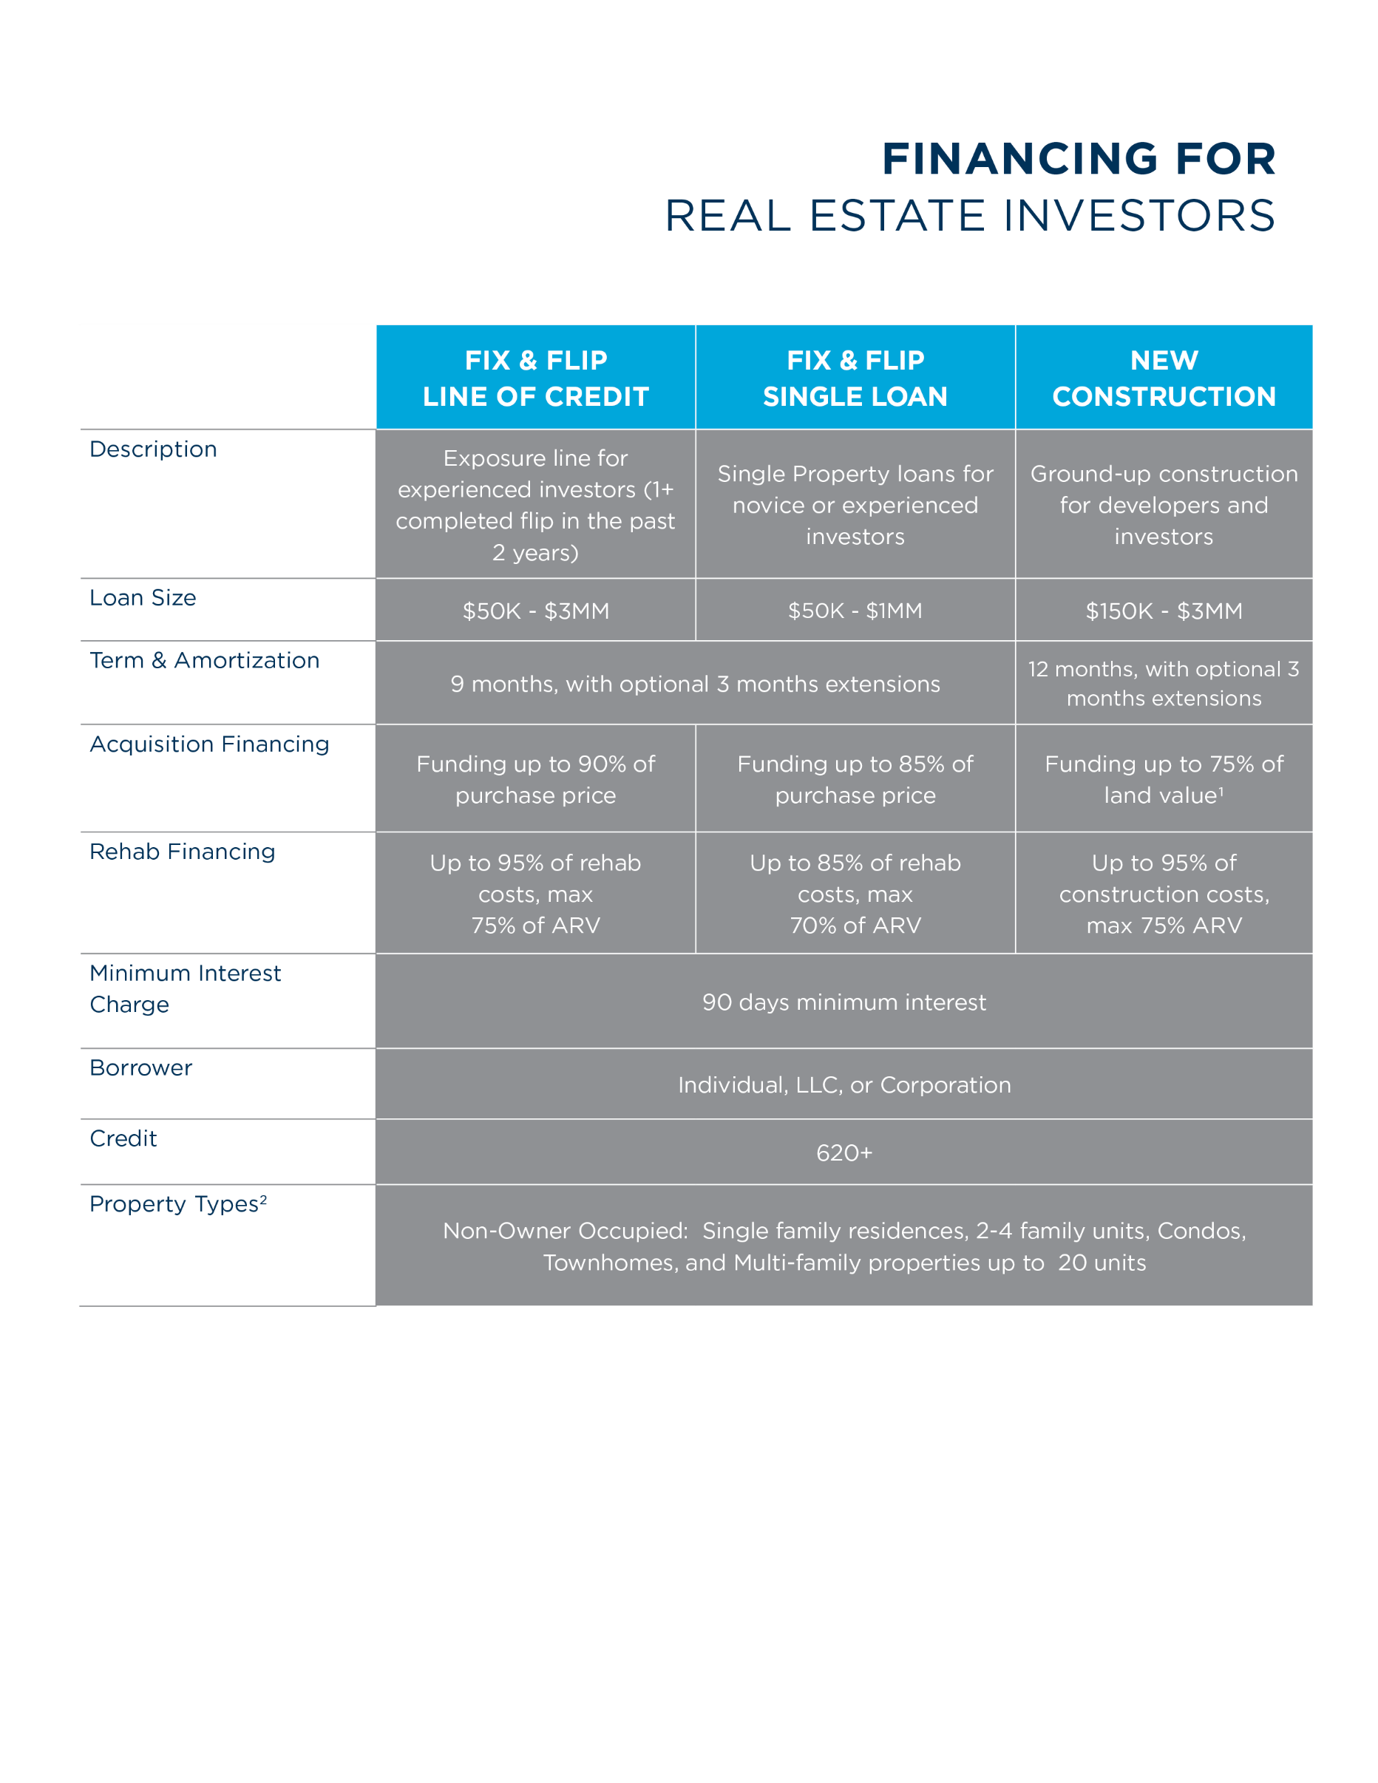
1. Land must be already improved/developed for use (ie., ready for utilities and plumbing.) All applicable building permits must be submitted; if building permits not submitted, funding limited to 60% of lower of land value or purchase price. 2. New Construction Single Loans are ineligible for multi-family property types and New Construction loans are ineligible for condo property types. REV. 10.03.2017.

Broker featured in this advertisement is not employed by Finance of America Commercial LLC and their affiliation with Finance of America Commercial LLC is limited exclusively to the commercial loan products they can offer through their broker relationship with Finance of America Commercial LLC.
Product offered through Finance of America Commercial LLC | | NMLS ID # 1133465 | Product not offered in all states. | Loans are subject to investor and business credit approval, appraisal and geographic location of the property and other underwriting criteria. Loan amounts and rates vary depending upon loan type, LTV, verification of application information and other risk based factors. Application fees, closing costs and other fees may apply.

